**SUPPLIER PANEL FLOW CHART**

1. **Dashboard**

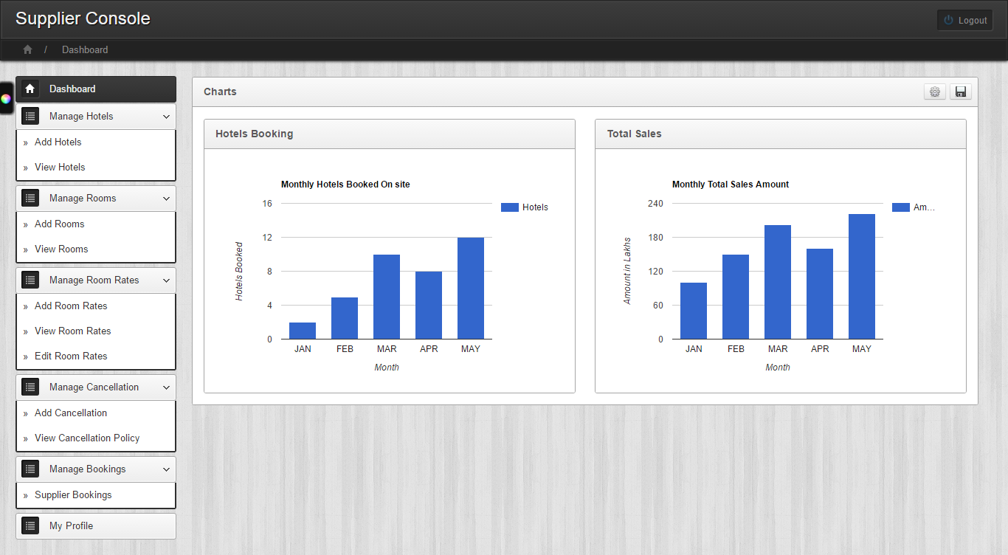

1. **Add Hotels -** General

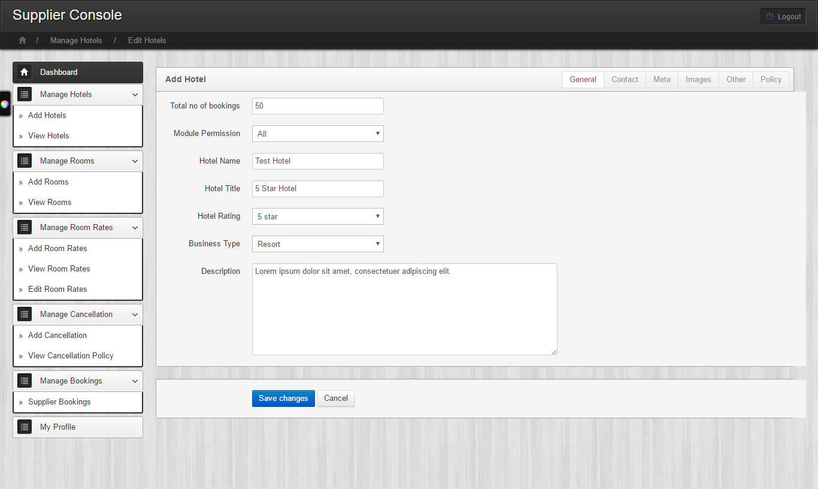

1. **Add Hotels -** Contact

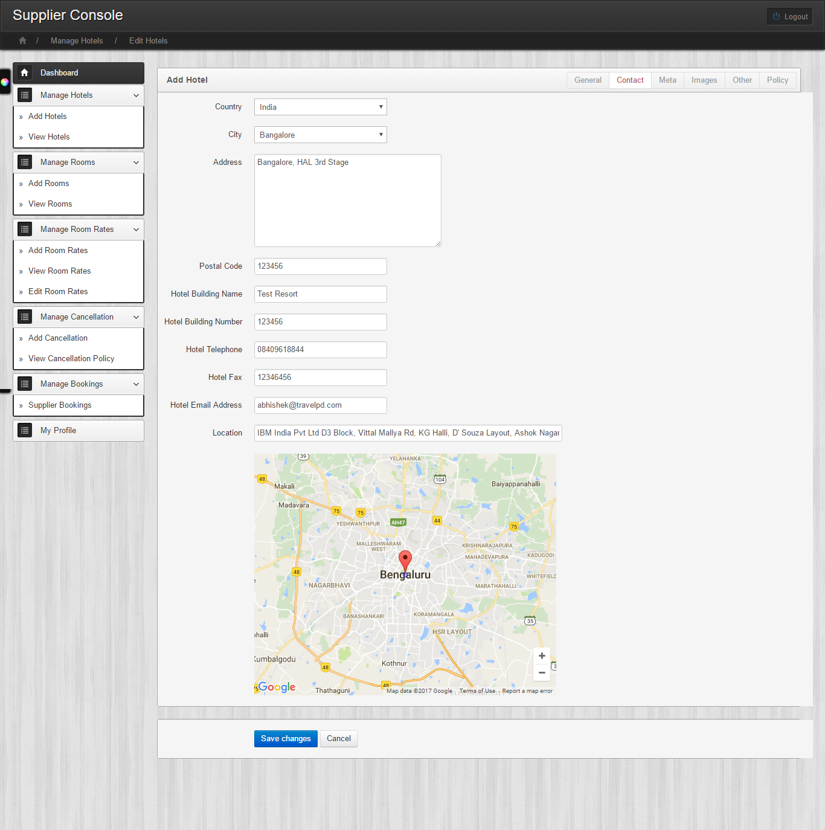

1. **Add Hotels -** Meta

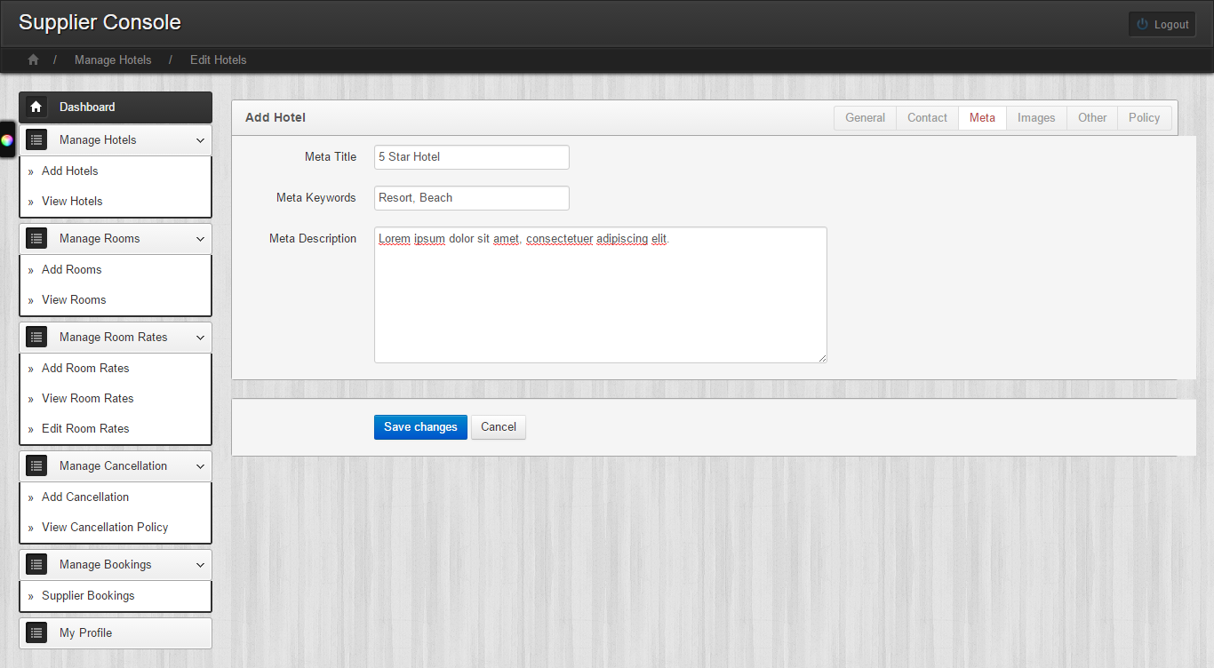

1. **Add Hotels -** Images

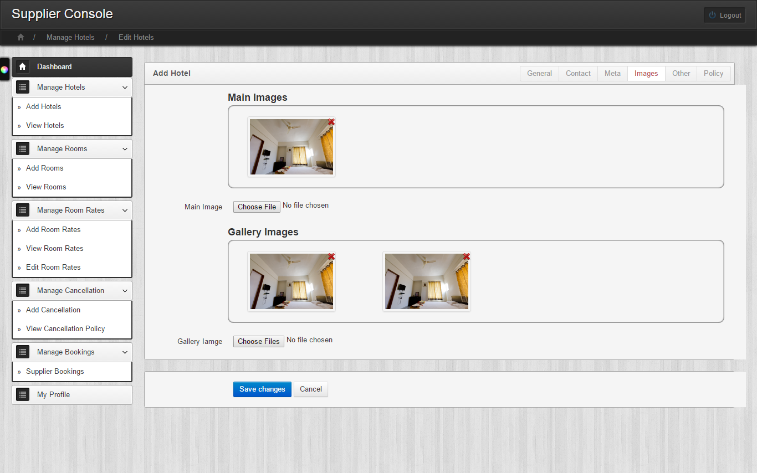

1. **Add Hotels -** Other

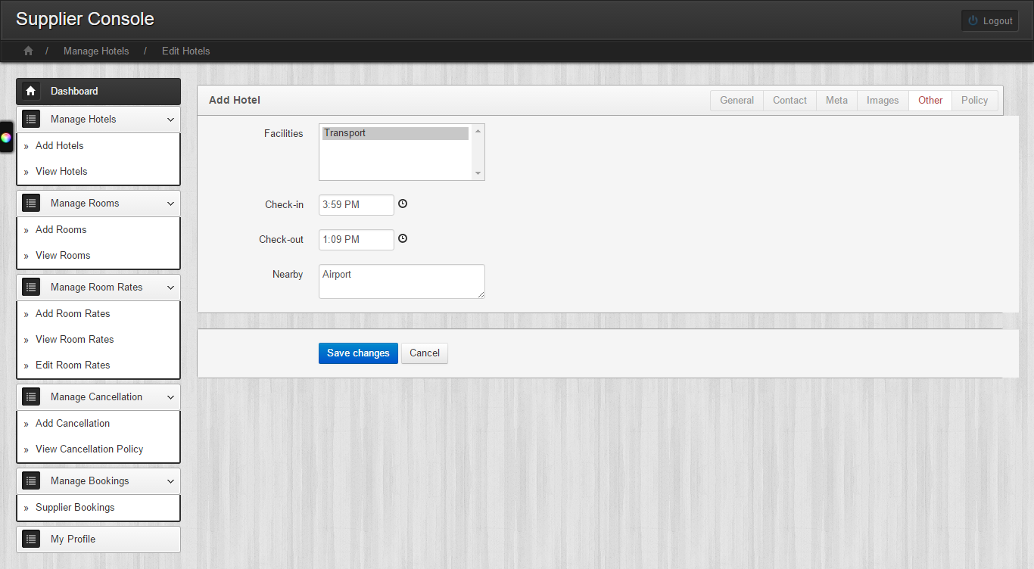

1. **Add Hotels -** Policy

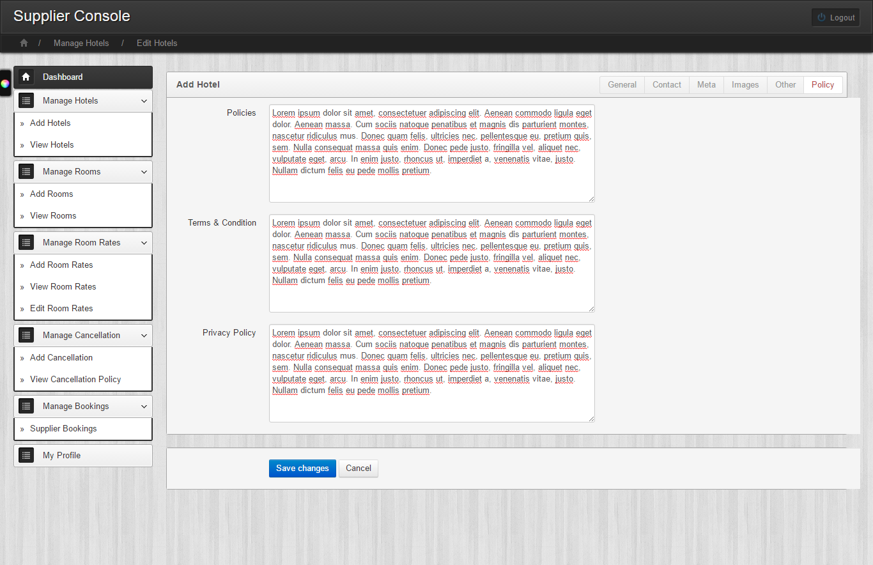

1. **View Hotels**

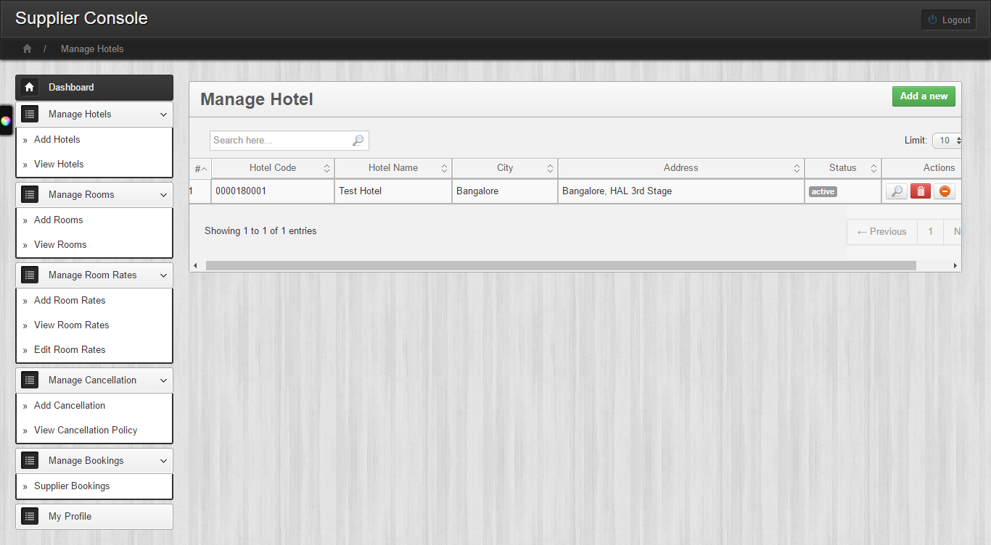

1. **Add Rooms**

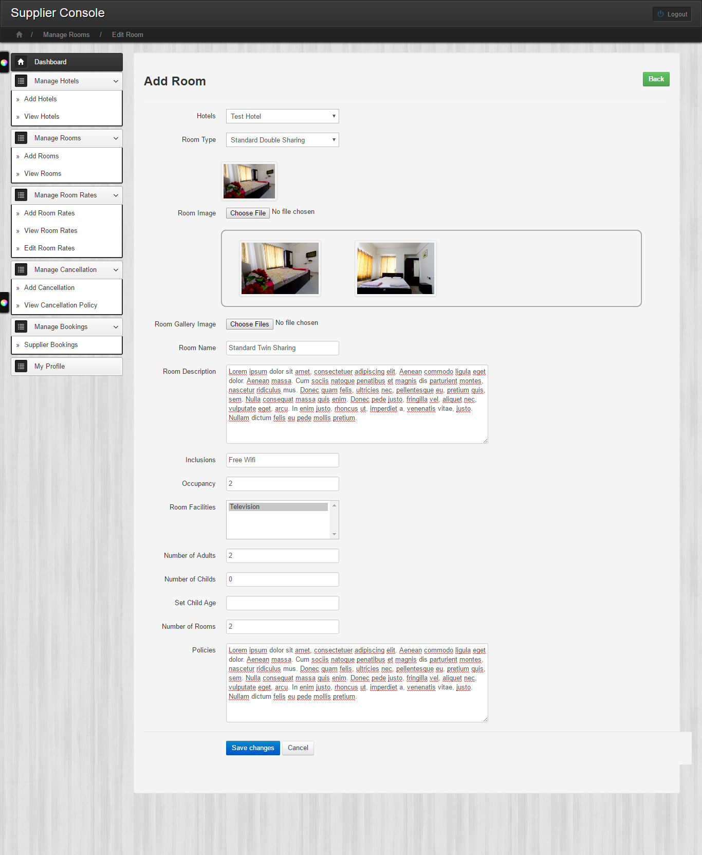

1. **View Rooms**

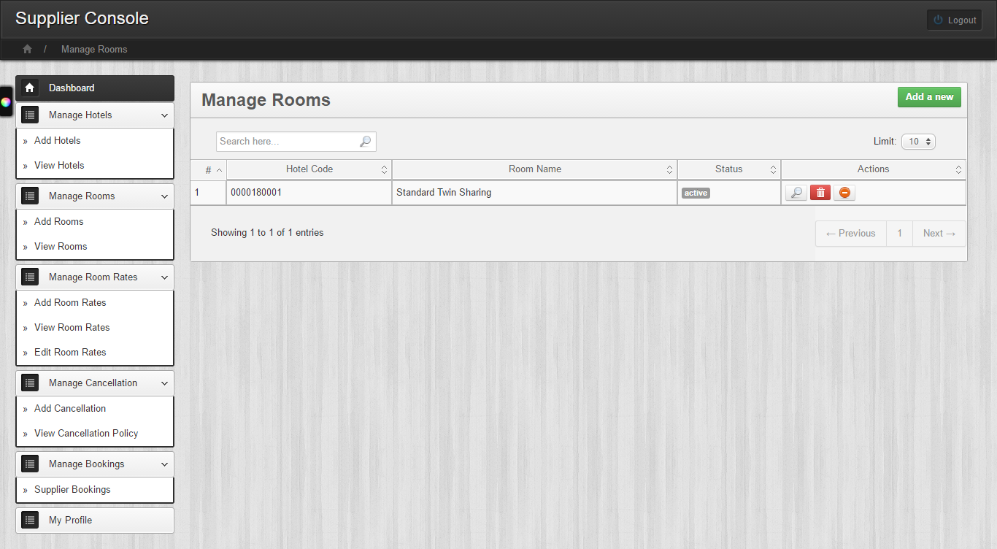

1. **Add Room Rates**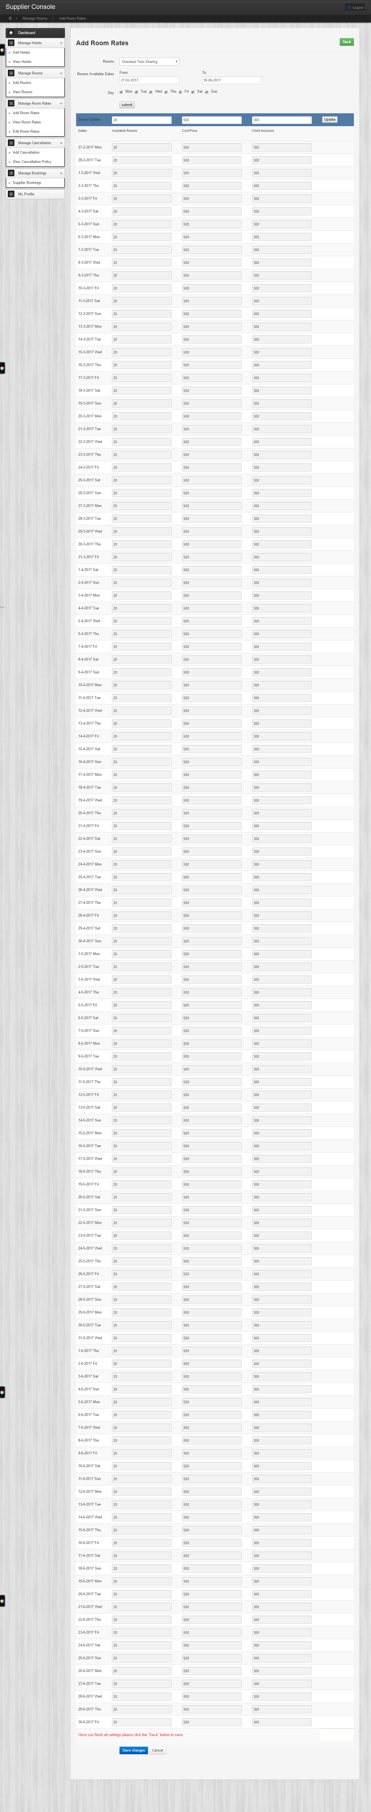
2. **View Room Rates**

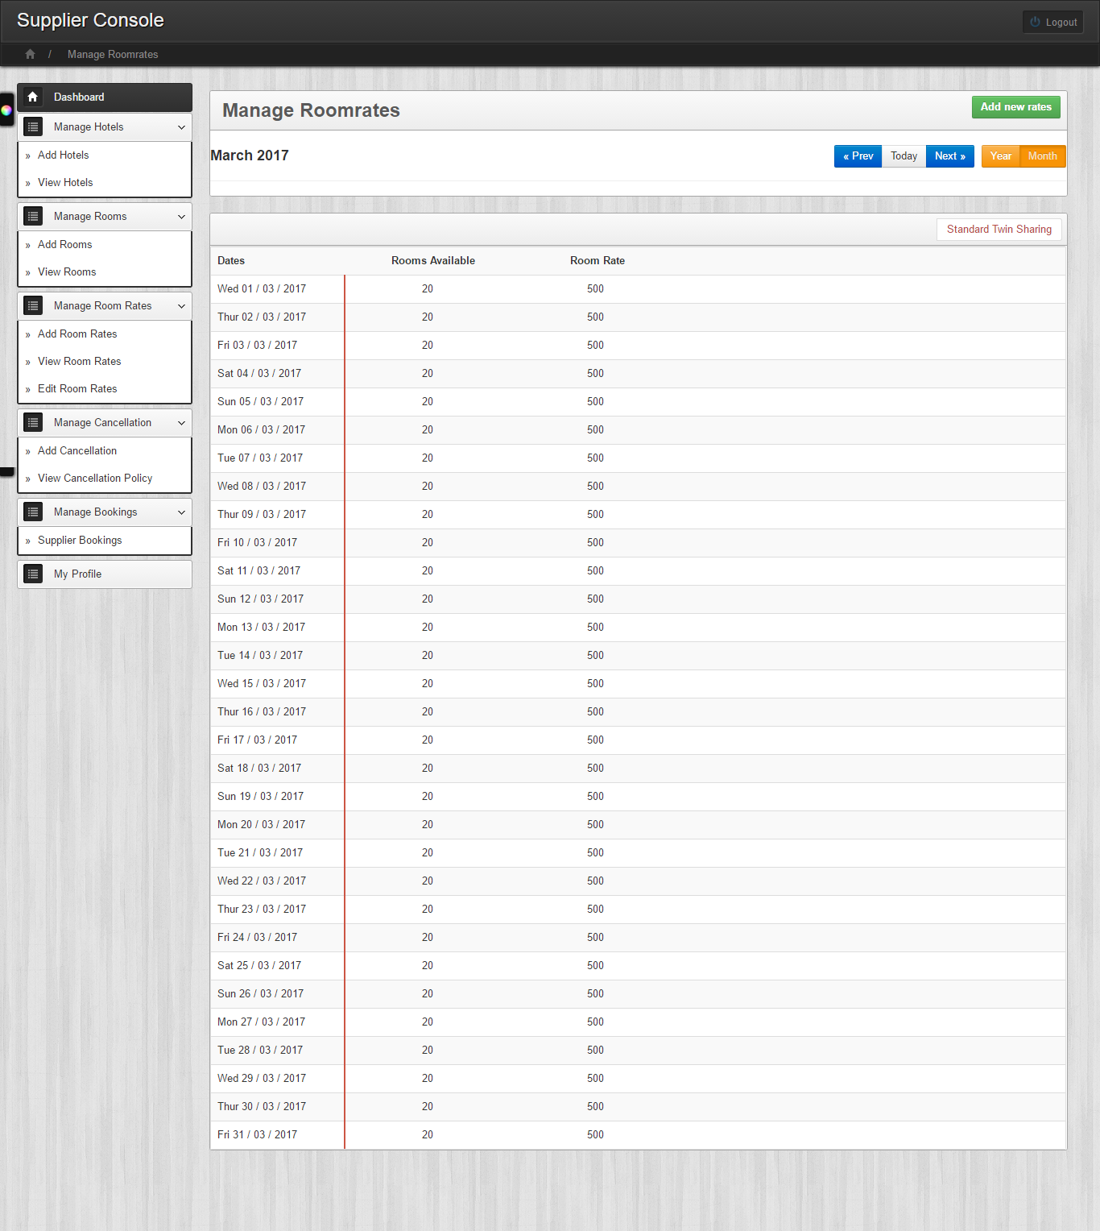

1. **Edit Room Rates –** Step 1

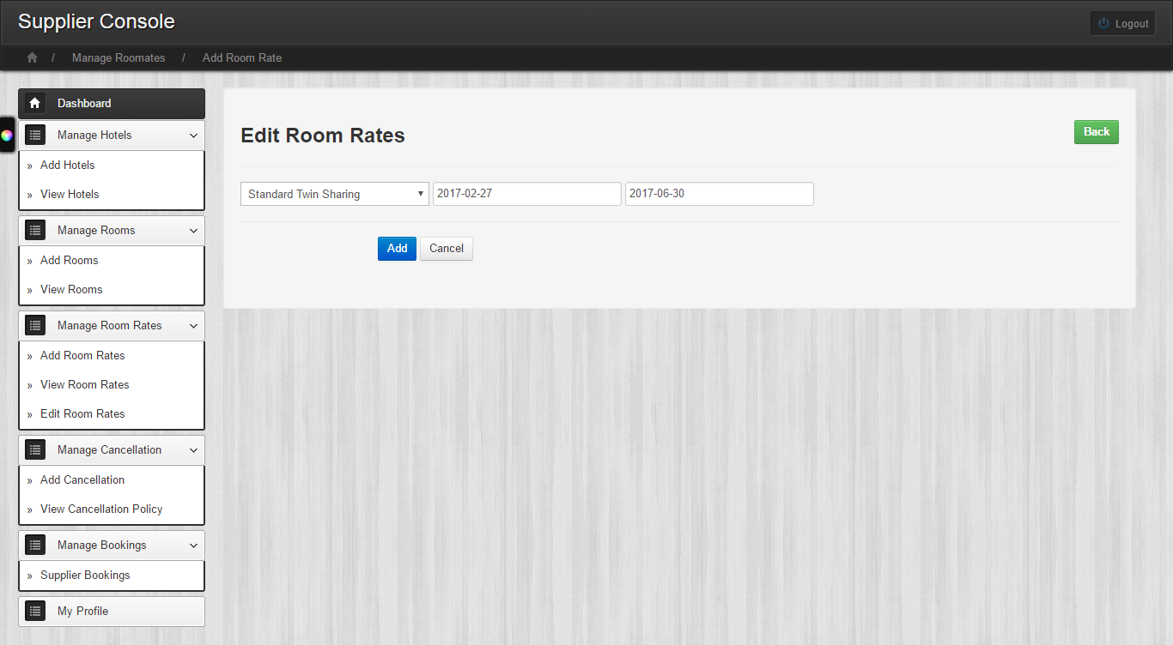

1. **Edit Room Rates –** Step 2

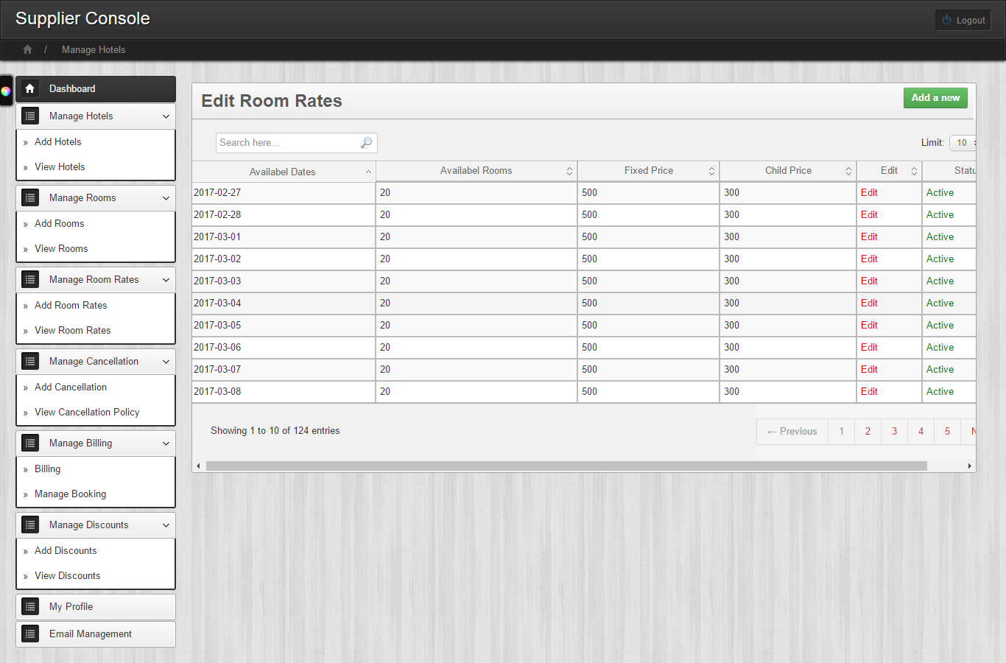

1. **Edit Room Rates –** Step 3

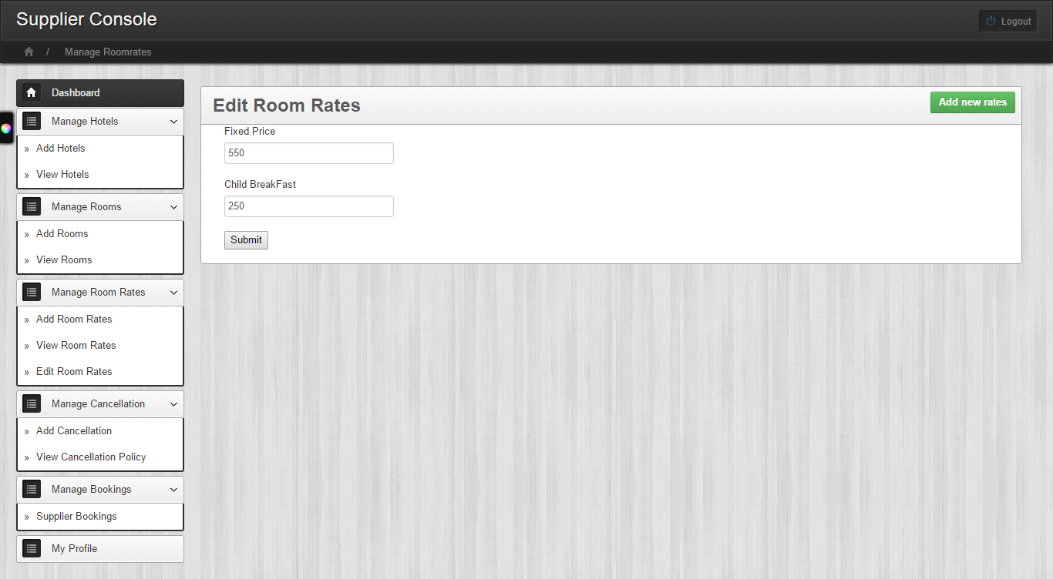

1. **Add Cancellation**

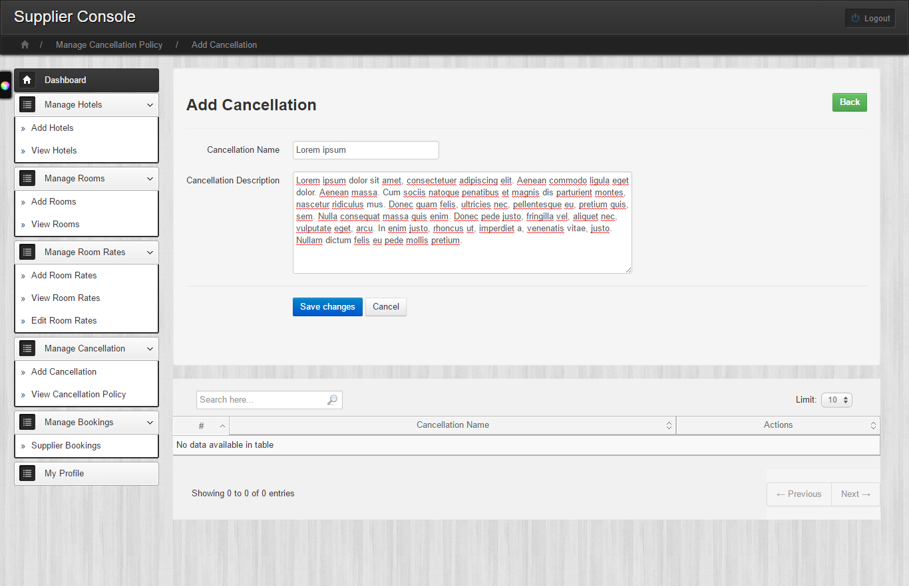

1. **View Cancellation**

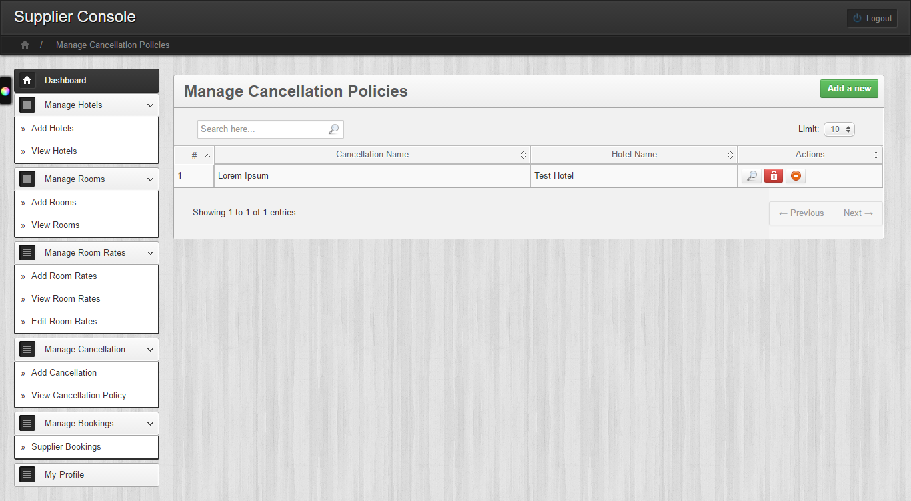

1. **Booking Reports**

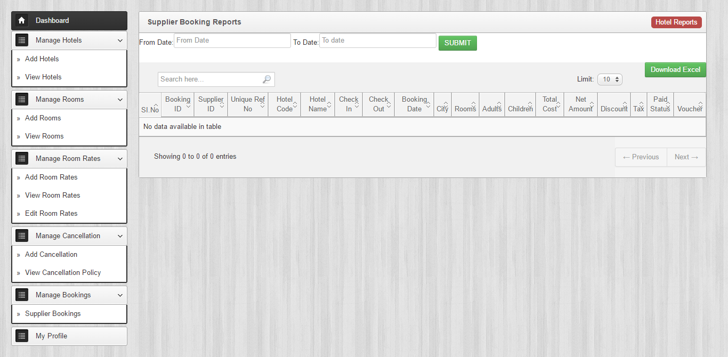

1. **My Profile**

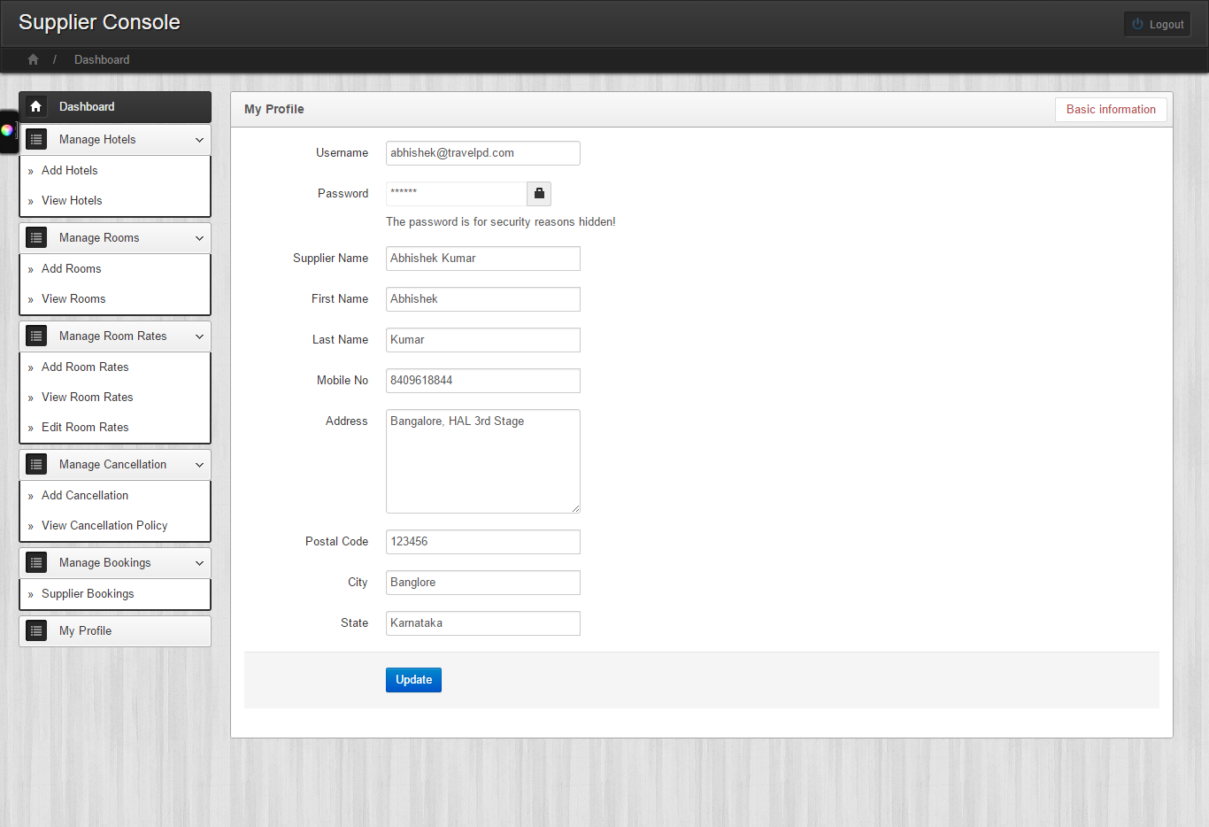

1. **Admin –** Add Hotel Facility

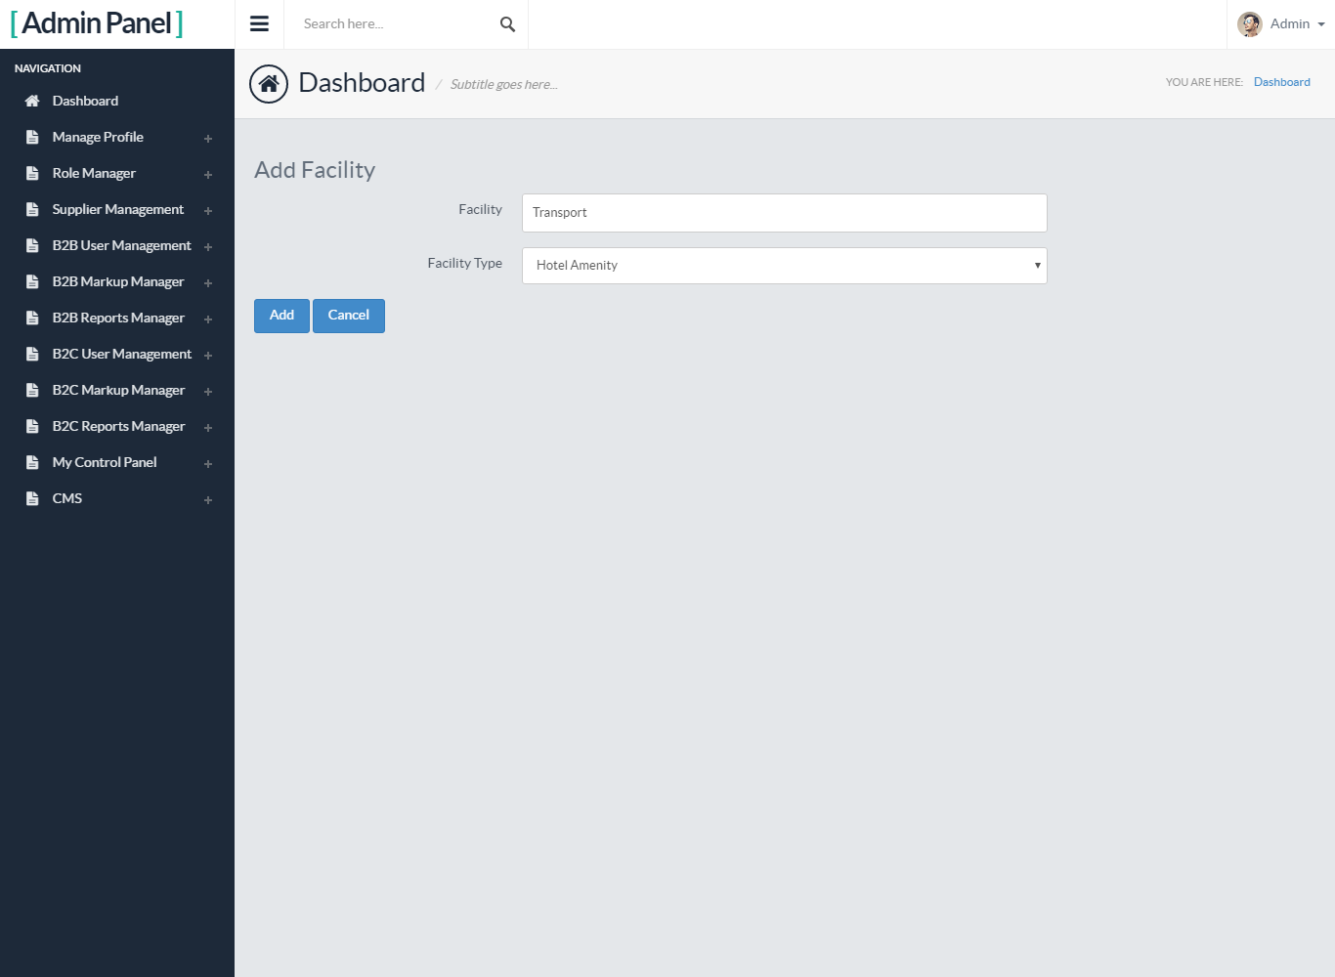

1. **Admin –** Add Room Facility

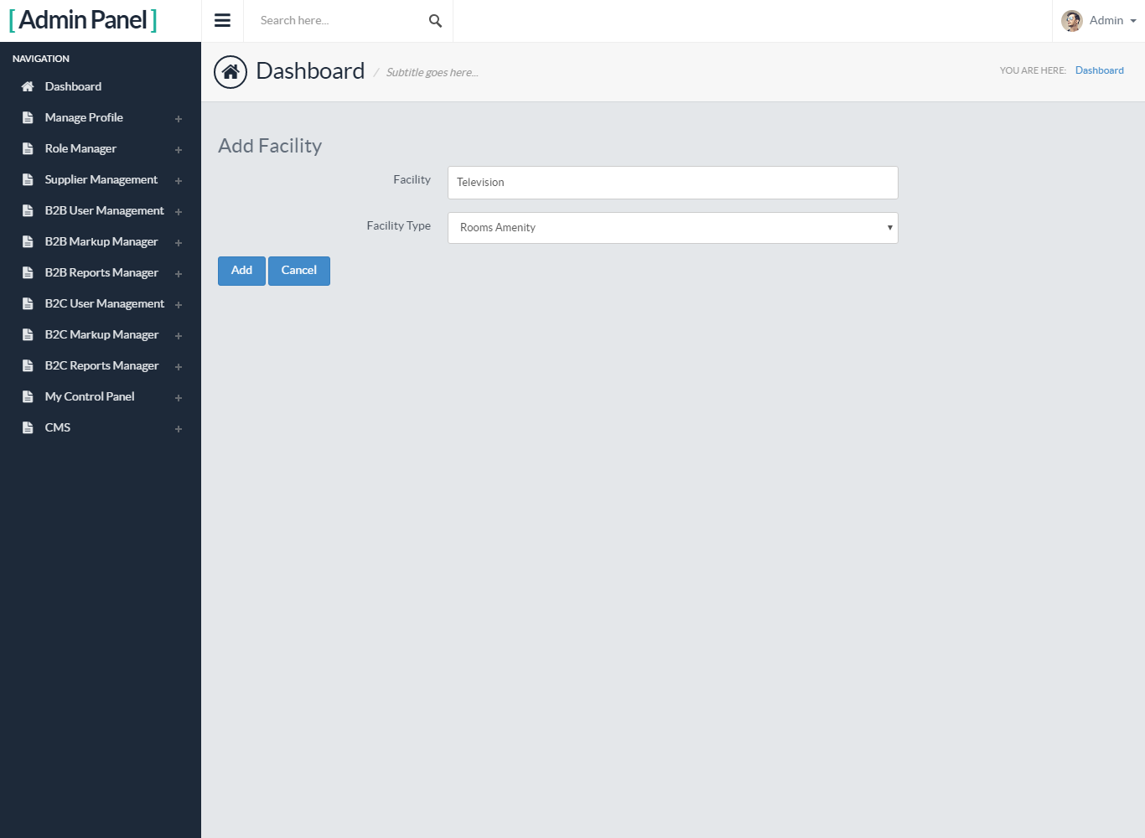

1. **Admin –** Add Room Types

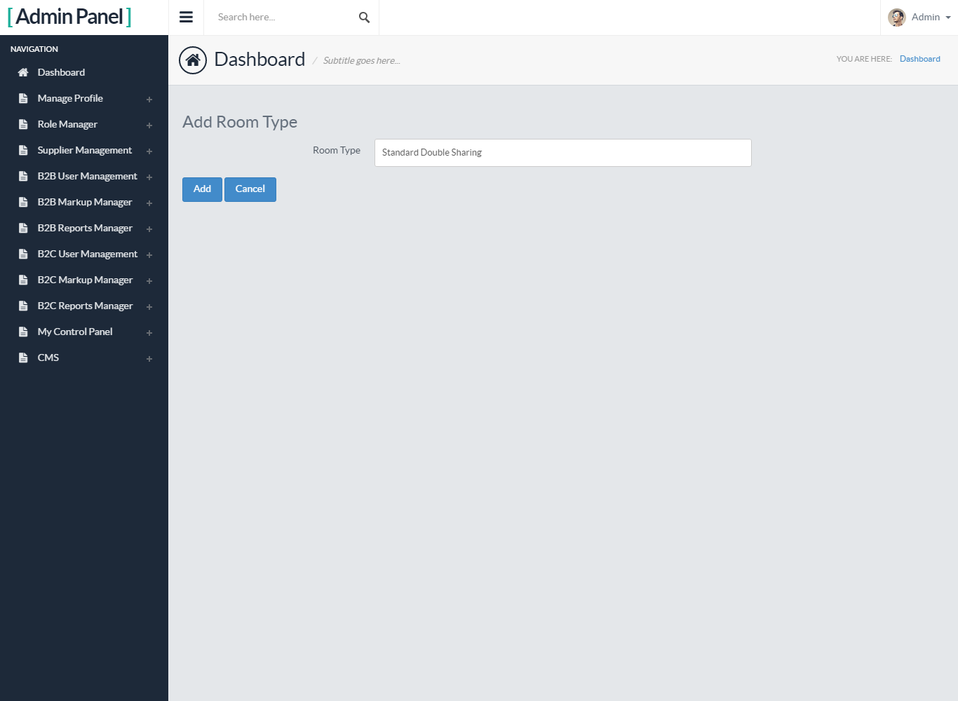

1. **Admin –** Add Business Type

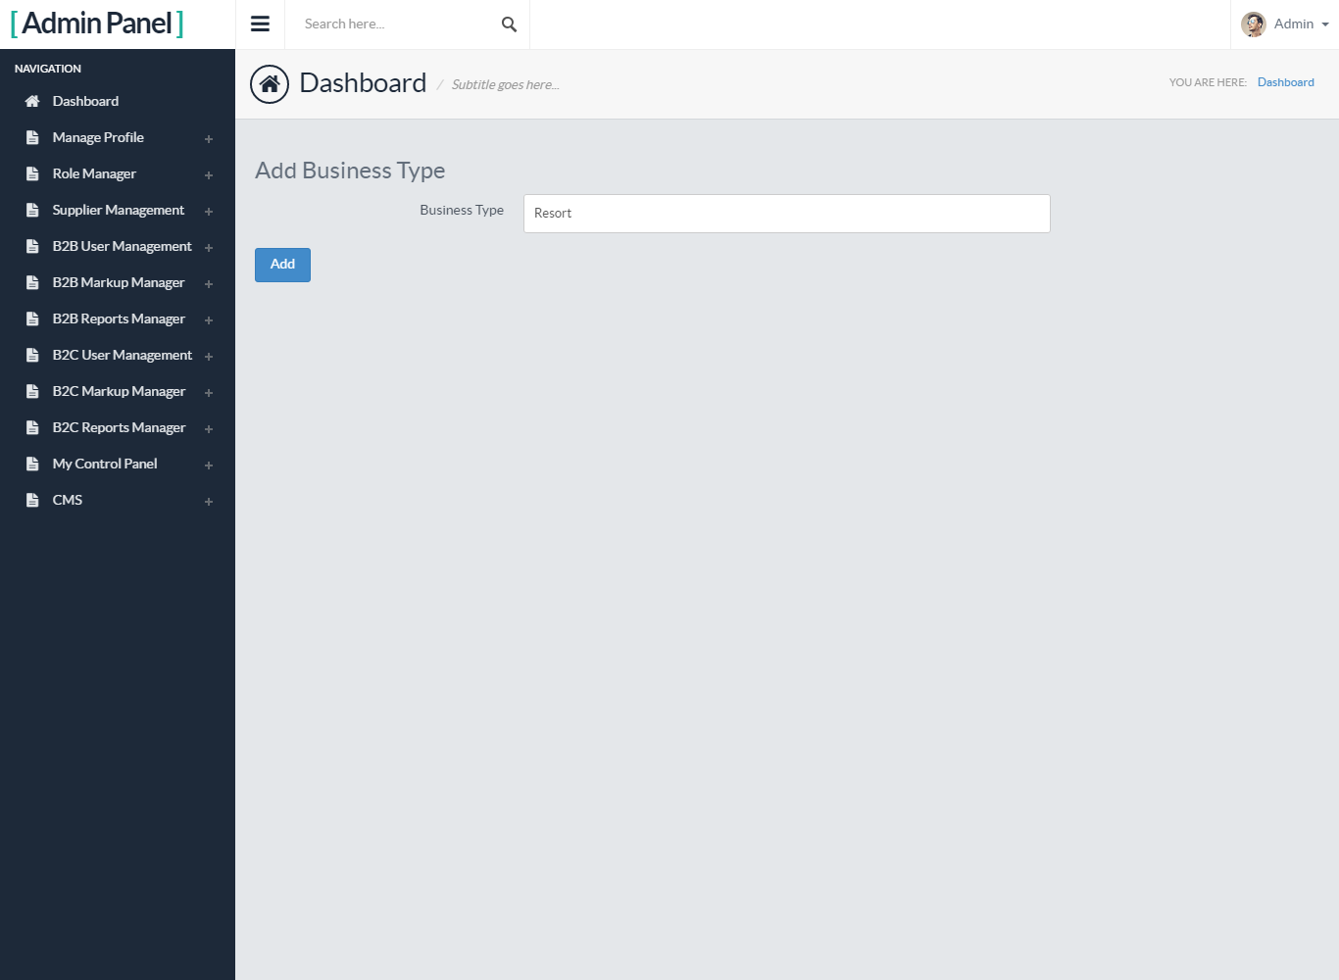

1. **Add Reviews**

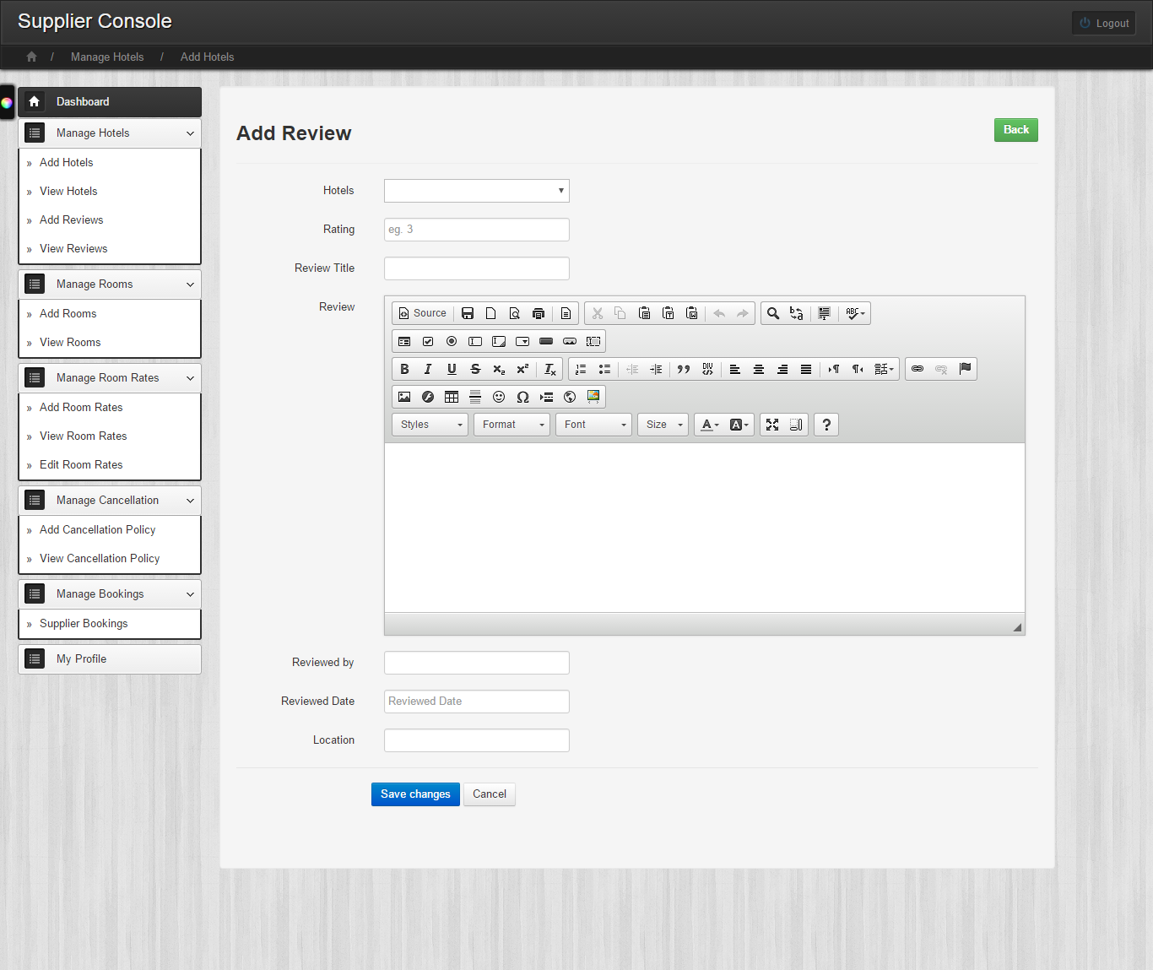

1. **Extrabed Add Room**

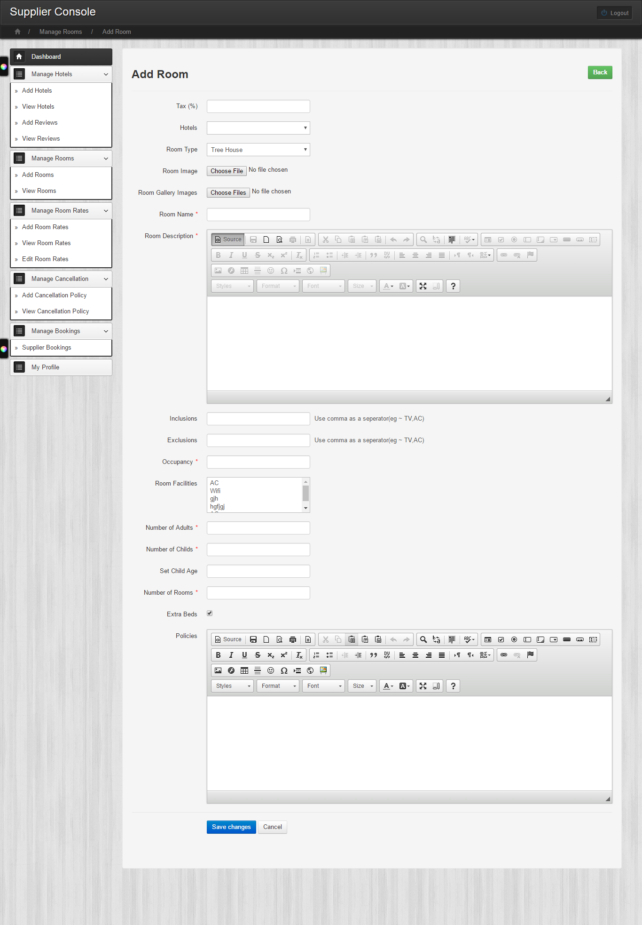

**Note –** If mentioned images are not visible properly, then please refer the separately attached images. Attached images are ordered as documentation.